
Company
Logotype

Cone Beam Computed Tomography- Report



Porur Dental X-rays & CBCT

Patient Name : Mrs. Shobana | Date of Report : 06.07.2024
Age/ Gender : 50 years/ Female | Region of Interest : CBCT Mandible
Referring doctor: Dr. Suchitra Mohan | Indication : Implant assessment
Clinical Notes: Nil
PATIENT INFORMATION

CBCT- Mandible provided
CBCT – IMAGE DETAILS

RADIOGRAPHIC INTERPRETATION

- In 36, 37, 46, presence of hyperdense crown structure and restorative material within the pulp canal extending upto the apical third of the root is evident.
- The mandibular alveolar ridge is present with normal trabecular pattern.

IMPLANT ASSESSMENT

 | 36 region | 37 region | 46 region
Sub-Crestal (in mm) | 9.66 | 9.54 | 9.25
Mid- Crestal (in mm) | 11.3 | 11.3 | 10.9
Distance between alveolar ridge and the inferior alveolar nerve canal (in mm) | 19.06 | 18.72 | 20
Distance between alveolar ridge and the inferior border of mandible (in mm) | 27.43 | 26.82 | 28.56

RADIOGRAPHIC IMPRESSION

- Root canal treated teeth: 36, 37, 46

Kindly correlate with clinical findings


IMAGES FOR REFERENCE

RECONSTRUCTED PANORAMIC VIEW
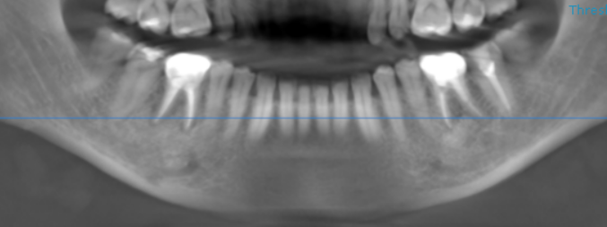

3-DIMENSIONAL VIEW

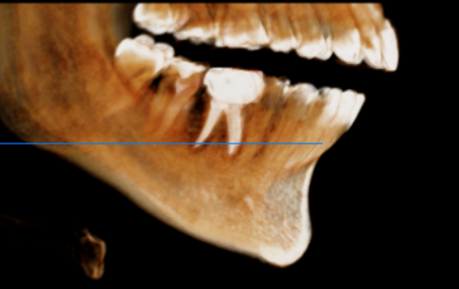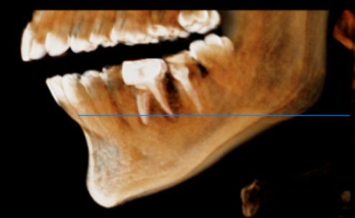

CROSS SECTIONAL VIEW

36 region | 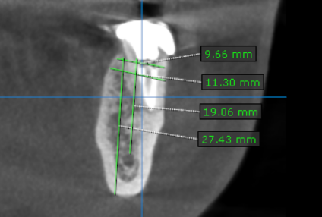
37 region | 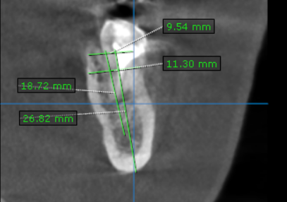
46 region | 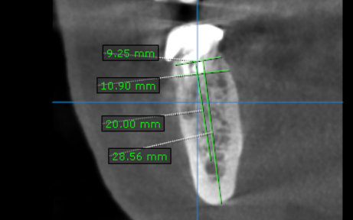

**** End of report ****

